- Tools for Troubleshooting Theory

- List three real-life scenarios where a multimeter would be used to troubleshoot a computer or smartphone issue, and explain in one line how the multimeter helps in each case?

Answer:
- Laptop not turning on: A multimeter can check whether the laptop charger is giving the correct output voltage.
- Smartphone not charging: A multimeter can check the charging port, battery voltage, and power supply to find the faulty part.
- Desktop PC has no power: A multimeter can test the computer power supply and check whether proper voltage is reaching the motherboard.

- Watch a short YouTube video demo of a POST card in action and write a brief summary?

Answer:
The BIOS performs the POST test when the computer starts, and the POST card displays the error code. In the video, it showed 00/0000, which indicated a motherboard startup problem.

- Download and install any free software diagnostic tool, run it on your laptop or desktop, and take a screenshot of the main dashboard showing system health details?

Answer:
I installed and used Speccy to check my laptop’s hardware health. It shows details about the CPU, RAM, motherboard, graphics, storage, and temperature.

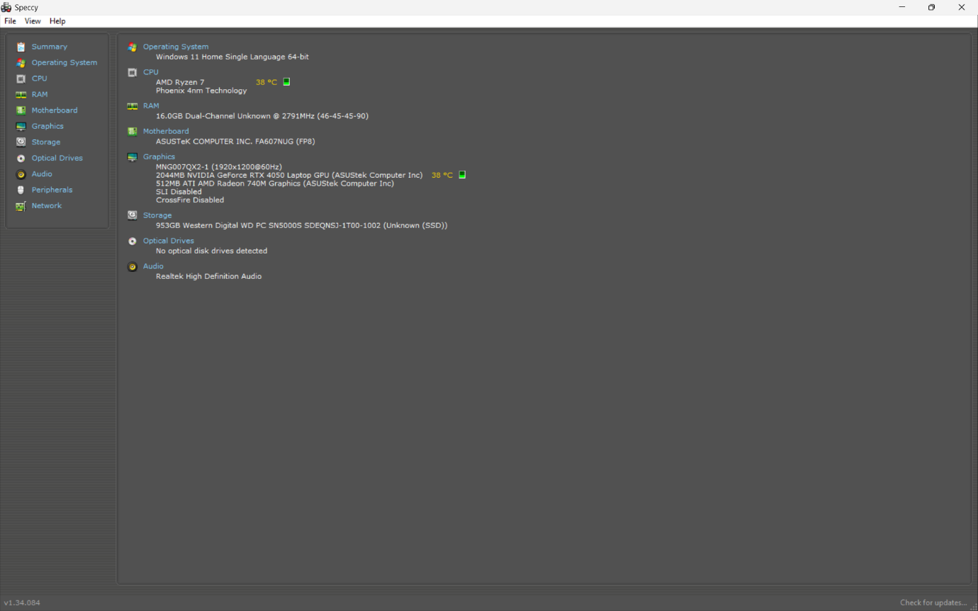

- Compare the use of a multimeter, POST card, and software diagnostics?

Answer:
Tool | What it checks | Example Problem Detected
- Multimeter | Voltage, current, resistance and electrical continuity | Faulty charger or power supply
- POST Card | Motherboard POST/startup diagnostic codes | Motherboard failing during startup
- Software Diagnostics (HWMonitor) | Temperature, voltage, fan speed and hardware sensor information | CPU overheating

Conclusion:
Multimeters, POST cards, and software diagnostic tools are useful for finding different computer hardware problems. A multimeter is mainly used for electrical testing, a POST card is useful for motherboard startup problems, and diagnostic software helps monitor the health and performance of computer hardware.

